Computer Networks & Data Communication

Design and Implementation of a Small Office Network using DHCP and DNS

Project Report 1

Submitted To: Mr. Muhammad Farooq

Submitted By: Dushant Raja

Registration No: 2312232

Table of Contents
Table of Contents 1
Abstract 2
1. Introduction 3
1.1. Background 3
1.2. Objectives 4
2. Network Design 4
2.1. Topology 4
2.2. Components 5
2.3. IP Addressing Scheme 6
3. Configurations 7
3.1. Router Configuration 7
3.2. Switch Configuration 9
3.3. DHCP Configuration 9
3.4. Advanced Router Configuration (DHCP Relay) 10
4. System Verification & Outputs 10
4.1. Router Routing Table 10
4.2. PC IP Configuration 11
4.3. Connectivity and DNS Test 12
4.4. DHCP Validation 12
4.5. DHCP and DNS Configuration 13
4.6. HTML Index Page 13
4.7. Web Server Configuration and Hosting 14
5. Conclusion 15
6. References 15

Abstract
This project details the design and implementation of a scalable Local Area Network (LAN) for a small office environment using Cisco Packet Tracer. The primary objective was to engineer a segmented architecture for four functional domains: HR, Sales, IT, and a Centralized Server Farm.
By utilizing a hierarchical model with a central router and Layer 2 switches, the design ensures logical isolation and efficient inter departmental routing. A structured Class C IPv4 subnetting scheme was implemented to optimize address space and minimize broadcast domains. To enhance administrative efficiency, the network integrates dynamic services, including a DHCP server for automated IP provisioning and a DNS server for internal hostname resolution.
The infrastructure was rigorously validated through ICMP testing and configuration audits, confirming seamless connectivity and service delivery. This project demonstrates a secure, high performance networking solution tailored for the operational demands of a modern enterprise.

Introduction

Background
In the modern era of digital transformation, the reliability and efficiency of a Local Area Network (LAN) are paramount to the success of any small-to-medium enterprise (SME). As businesses grow, the demand for organized data flow, resource sharing, and secure communication increases. A flat network where all devices reside in a single broadcast domain often leads to congestion, security vulnerabilities, and management difficulties. Consequently, network engineers utilize segmentation to divide a physical network into multiple logical subnets, each tailored to the specific needs of different departments like HR, Sales, and IT. To manage these segmented environments effectively, two core network services are essential: Dynamic Host Configuration Protocol (DHCP) and Domain Name System (DNS). DHCP eliminates the tedious and error-prone task of manual IP assignment by automatically leasing addresses to devices as they connect. Meanwhile, DNS provides the human-centric layer of the network, allowing employees to access internal servers and resources via easily recognizable names (e.g., officeweb.local) rather than complex numerical IP addresses. This project utilizes Cisco Packet Tracer, a powerful network simulation tool, to model these professional configurations in a risk-free, virtual environment before physical deployment.

Objectives
The primary goal of this project is to design and implement a multi-subnet small office network that demonstrates core routing and switching principles. The project focuses on creating a well-structured and efficient network by dividing it into four distinct segments—HR, Sales, IT, and Servers—to enhance security and reduce unnecessary broadcast traffic. It also involves configuring a central Cisco router to enable inter-VLAN routing, allowing communication between different subnets while maintaining logical separation. In addition, a centralized DHCP service will be implemented, either on a dedicated server or the router, to automatically assign IP addresses and related network settings to devices across all departments. To further improve usability, a DNS server will be deployed within the network to simulate an internal intranet environment, making resource access easier and more user-friendly. Finally, the performance and reliability of the network will be verified through comprehensive testing, including connectivity checks using ping, confirmation of DHCP IP address assignment, and successful DNS name resolution.

Network Design

Topology
The "Small Office Network" is designed using a Three-Layer Hierarchical Model, consisting of the Core, Distribution, and Access layers. This structure provides a scalable and redundant framework, allowing for the seamless integration of multiple departmental networks while maintaining high performance and security.

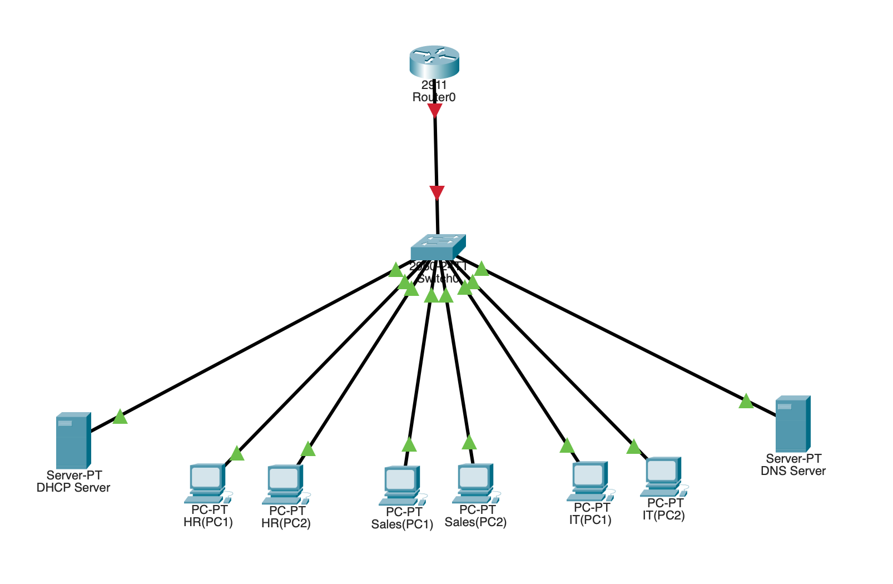

Components
- 1 Router: Acts as the "Core" of the network. It handles inter-VLAN routing (Router-on-a-Stick) and serves as the default gateway for all subnets, allowing traffic to move between HR, Sales, IT, and the Server Farm.
- 2 Switches: Serves as the "Distribution" and "Access" layer hub. It manages VLAN and provides physical connectivity for all end-user workstations and servers.
- DHCP Server: A standalone server responsible for the dynamic allocation of IP addresses to the HR, Sales, and IT departments.
- DNS Server: A standalone server providing hostname resolution services, allowing users to access resources via domain names instead of IP addresses.
- PCs: Standard client devices distributed across the office. These are configured for dynamic addressing to test the efficacy of the DHCP service.
- Copper Straight-Through Cabling: Used for all Ethernet connections between hosts, switches, and the router to support high-speed data transfer.

IP Addressing Scheme
SR No. | IPv4 Address | Subnet Mask | Default Gateway | DNS
HR(PC1) | 192.168.10.2 | 255.255.255.0 | 192.168.10.1 | -
HR(PC2) | 192.168.10.3 | 255.255.255.0 | 192.168.10.1 | -
Sales(PC1) | 192.168.20.2 | 255.255.255.0 | 192.168.20.1 | -
Sales(PC2) | 192.168.20.3 | 255.255.255.0 | 192.168.20.1 | -
IT(PC1) | 192.168.30.2 | 255.255.255.0 | 192.168.30.1 | -
IT(PC2) | 192.168.30.3 | 255.255.255.0 | 192.168.30.1 | -
DHCP Server | 192.168.100.2 | 255.255.255.0 | 192.168.100.1 | -
DNS Server | 192.168.100.3 | 255.255.255.0 | 192.168.100.1 | -

Configurations

Router Configuration
We can do router configuration by these CLI commands:
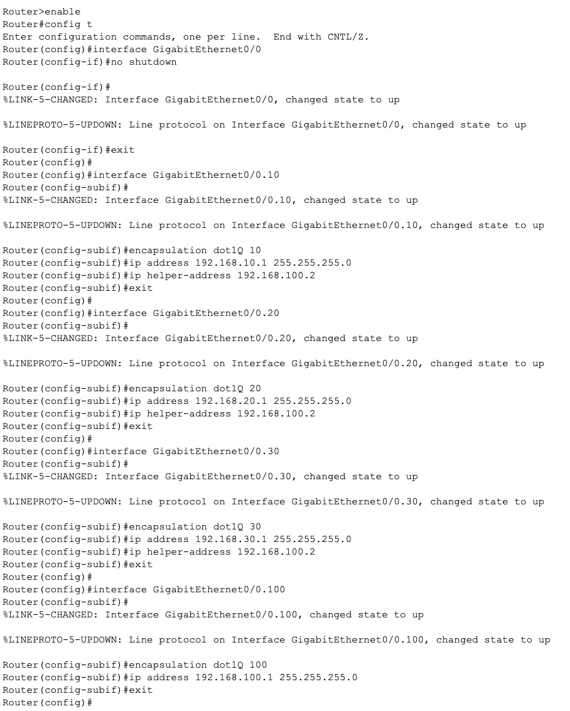

Switch Configuration
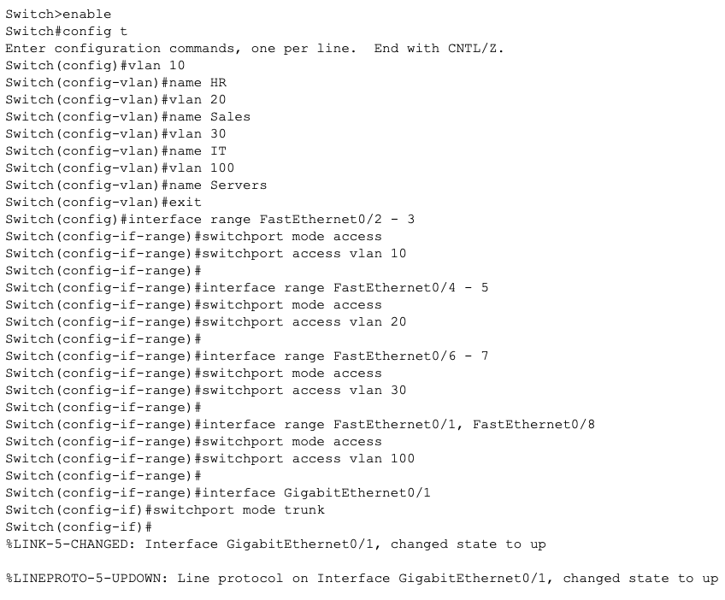

DHCP Configuration
The DHCP Server is configured with three distinct address pools. Each pool is mapped to a specific department to ensure clients receive the correct gateway and DNS information.
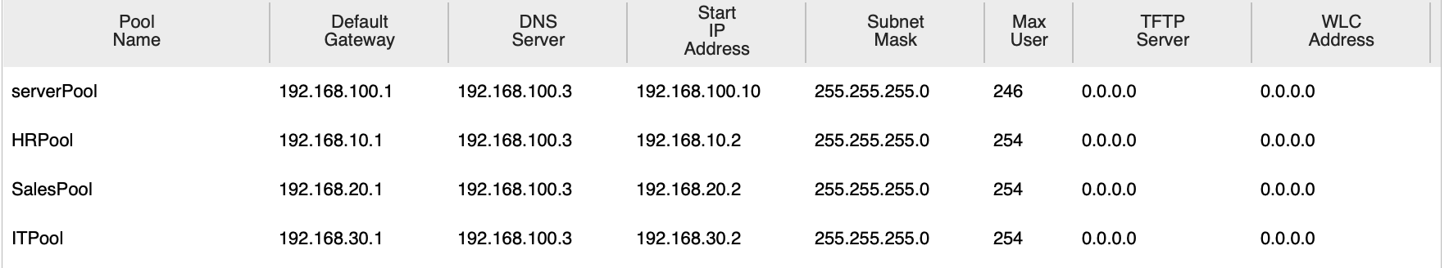

Advanced Router Configuration (DHCP Relay)
Because the DHCP server sits in a different subnet (VLAN 100) than the client PCs, the router must be configured as a DHCP Relay Agent. This is achieved by applying the ip helper-address command to the departmental sub-interfaces, pointing specifically to the DHCP Server IP.
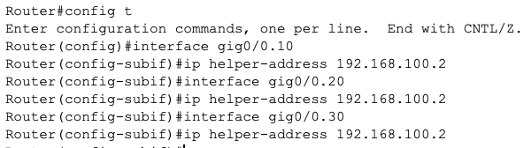

System Verification & Outputs

Router Routing Table
The routing table is the "brain" of the network. This output confirms that the Router recognizes all four VLANs as directly connected through its sub-interfaces. We can give this command to Router CLI: show ip route.
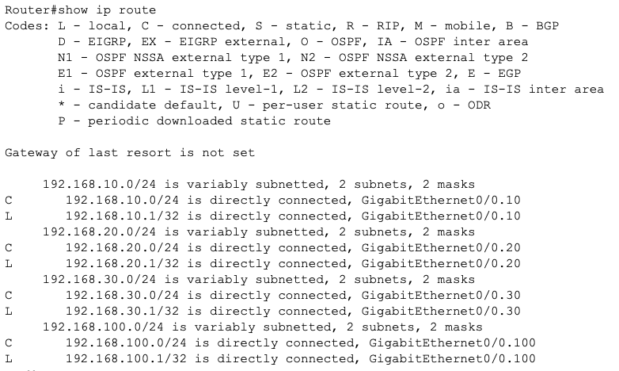

PC IP Configuration
This output proves that the DHCP Server (192.168.100.2) successfully assigned an IP address to a client in a different VLAN.
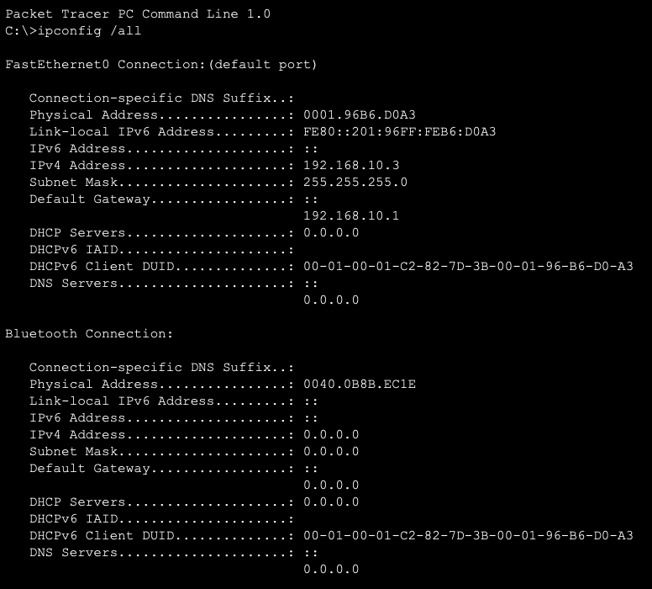

Connectivity and DNS Test
This output confirms that Inter-VLAN routing is working (Ping) and that the DNS Server (192.168.100.3) is resolving the internal domain. We can get this output by giving command to HR(PC1) : ping 192.168.100.3
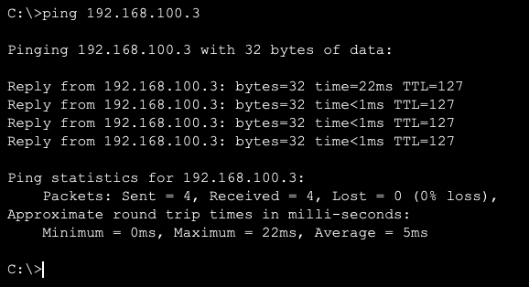

DHCP Validation
The implementation of a centralized DHCP Server within VLAN 100 successfully automated IP addressing across all departmental subnets. To overcome the limitation of broadcast traffic being confined to a single VLAN, the IP Helper-Address (DHCP Relay Agent) was configured on each router sub-interface. This allowed the router to intercept DHCP Discovery broadcasts from the HR, Sales, and IT departments and forward them as unicast packets to the server at 192.168.100.2. As evidenced in the attached screenshot, the client node HR(PC1) successfully transitioned from a static configuration to a dynamic state, receiving the IP address 192.168.10.10 with the correct Default Gateway (192.168.10.1) and DNS Server (192.168.100.3). This verifies that the DHCP pool "HRPool" is correctly scoped and that the relay mechanism is functioning as intended, ensuring high scalability for future network expansion.
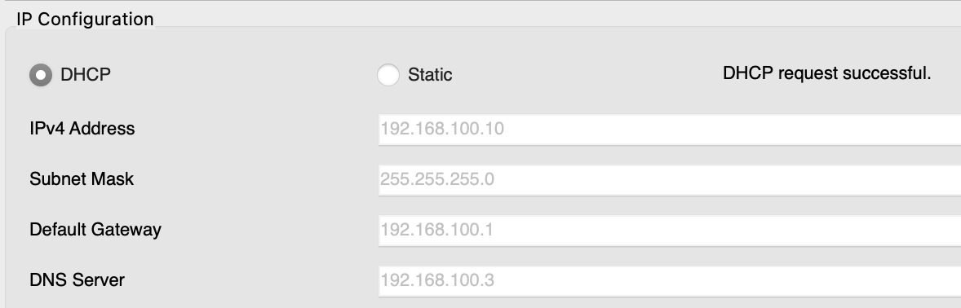

DHCP and DNS Configuration
A centralized DHCP pool was created for each department, ensuring automated IP allocation starting from .10. A DNS A-Record was established for the domain office.com, mapping it to the server IP 192.168.100.2
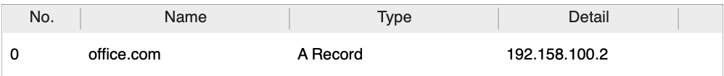

HTML Index Page
To validate the application layer, a custom HTML index page was coded and hosted on the HTTP service of the server.
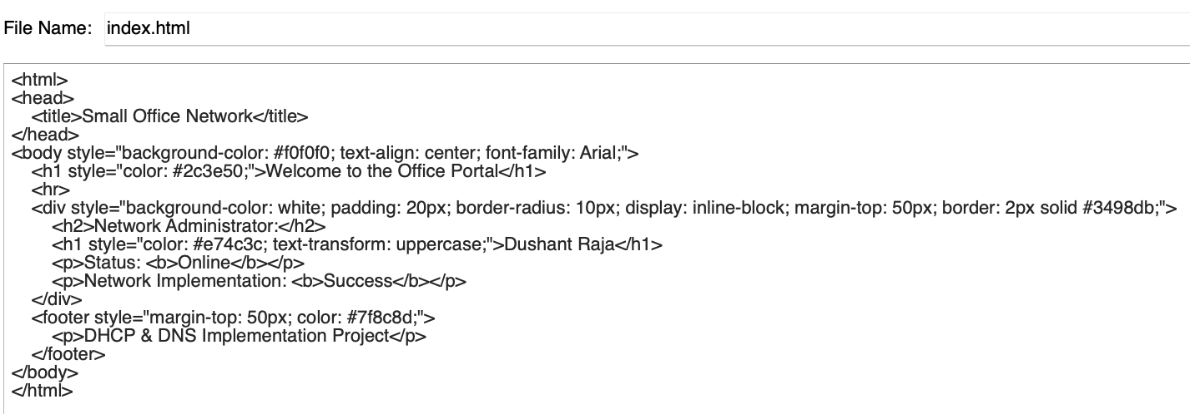

Web Server Configuration and Hosting
Once the HTML portal is developed, it must be hosted on a dedicated web server to be accessible across the office. This involves installing a service such as Apache or Internet Information Services (IIS) on the central server.
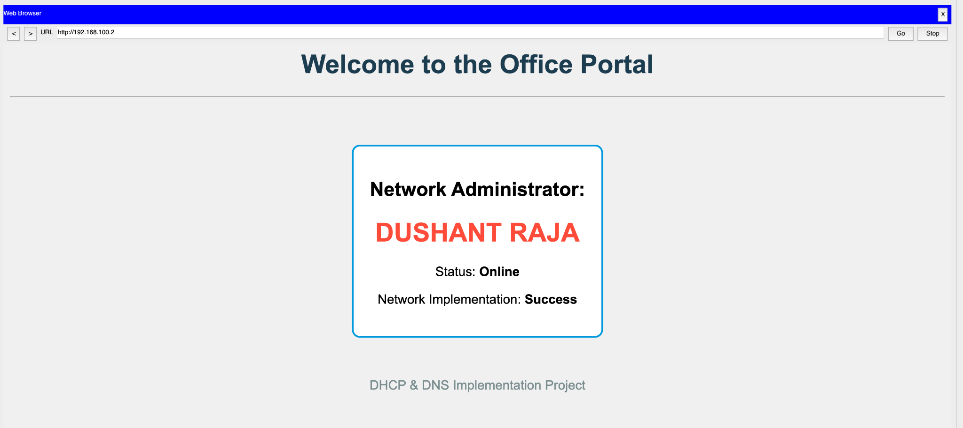
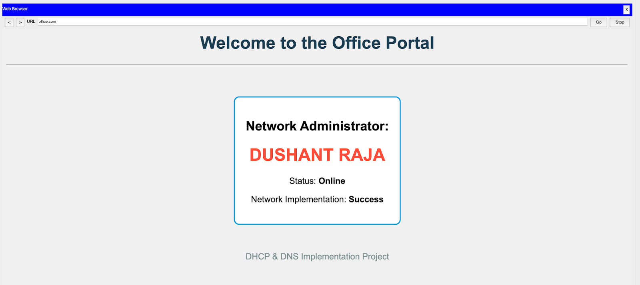

Conclusion
The project successfully demonstrates the integration of core networking concepts. By utilizing VLANs and a Router-on-a-Stick configuration, we achieved an efficient and scalable network environment suitable for a small-scale enterprise.

References
Cisco Networking Academy. (2024). CCNA: Introduction to Networks v7.0 (ITN). Cisco Press.

